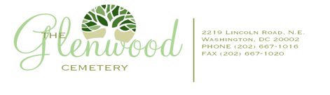

THE GLENWOOD CEMETERY PROXY & Ballot
FOR ANNUAL MEETING Monday June 6, 2016
Please return no later than June 3rd ,2016

PROXY

I/We, LOT OWNERS of
LOT ___ within the Cemetery wherein ____(#) internments have been made, submit this Proxy in lieu of personal appearance at the Annual Meeting of Lot Owners. The meeting will be held on Monday June 1st 2015 at 5pm. Location is Glenwood Cemetery Chapel.
This proxy and ballot may be withdrawn at or before the meeting. Please check only five candidates for the immediate board. The remaining two candidates will serve as an alternant.
- I want my proxy to be used for quorum purposes only.
- I cast my vote for the following (checked) nominated Candidates*:
- Edward Robinson
- Rosalie T. Peckerol-Jaccino
- Edward Bunch
- Lorraine Reddick
- Tina Hausen
In lieu of voting for a particular Board of Trustee candidate, I hereby appoint the current President/ Edward Robinson of Glenwood Cemetery as the nominee of the undersigned to attend and act for the undersigned at this Annual Meeting as if the undersigned were present at the said meeting and to make any and all votes in my stead as may be required of Lot Owners during said meeting, including the election of Trustees to the Board
Dated this day of 2016
Name of Lot Owner
Signature
OFFICIAL USE ONLY
Proxy Verification: __________________________________________________________________
Please feel free to also visit The Glenwood Cemetery Website-www.theglenwoodcemetery.com for a 2016 Proxy.
You can fax it to 202-667-1020 To Board of Trustees

